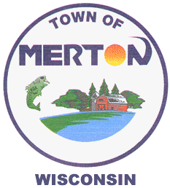

- Transfer Station is not closing. It would no longer collect garbage

- Waukesha County is going from a dual stream recycling collection to a single sort recycling collection, which does not require all the sorting

- Waukesha County is providing financial assistance for recycling carts and direct hauling costs to communities with a municipal contract, size to be determined upon method

- Increased Recycling equals increased program revenue and saves on landfill disposal fees, which is the purpose of the larger recycling carts

- Town of Merton is 1 of 3 municipalities in the program not offering a municipal trash/recycling collection in Waukesha County

- Proposal includes the following options:
Automated curbside collection (most cost savings) $ 150 - $165.00/yr

Manual Up the Drive $ $220 - $235.00/yr

Automated plus a hybrid premium for Up the Drive Subject to negotiation

All include pickup of bulky items Included on all

Provisions for the elderly and handicapped

Yard Waste is not included at this time because of contract with Town of Lisbon

Contract would be for 7 years with a 3 year extension option and a CPI/Fuel Surcharge with a maximum cap

Projected costs are still subject to negotiations

- Implementation would be January, 2015

